Smart solar hybrid electrical vehicle
First Author^{#1}, Second Author^{*2}, Third Author^{#3}
#First-Third Department, First-Third University
Address Including Country Name
¹first.author@first-third.edu
³third.author@first-third.edu
*Second Company
Address Including Country Name
²second.author@second.com

Abstract— To improve the quality of life is a part of encouraging the active life is providing the link between physical activities and quality of life and it should be well established among the physically disable people. Wheel-chair is important aspect that allows physically handicap person to be an active element of society by giving his contribution to growth of society.one of the best invention for physically handicap patients was wheelchair and we have taken another foot forward. Our research paper has discussed about the latest advancement in the wheel-chair design and facilities. The vehicle available in the market are base on indoor and outdoor uses.

Keywords-: wheelchair, disable people, solar, interface, sensor
- Introduction
According to the latest global reports on disability, more than one billion individuals, who nearly constitute 14% of the world population, live with some form of disability. Studies also indicate that approximately 10% of these individuals have lower limb disabilities, and are dependent on manually propelled wheelchairs for performing activities of daily living. About 20 million of the disabled, however, do not have access to wheeled mobility devices. They often stuck in four walls without any community participation, as a result most wheelchair manufactures are coming forward with intelligent wheelchair.
The main functions of Intelligent wheelchair are:
- Interaction with the user, including hand-based control (such as, joystick, keyboard, mouse, touch screen); voice-based control; vision-based control and other sensor-based control (such as pressure sensors);
- Autonomous navigation (with safety, flexibility and robust obstacle avoidance);
- Communication with other devices (like automatic doors and other Wheelchairs).

- literature review
According to the review paper published by Simpson in 2005, there are many forms for designing a smart wheelchair. Early smart wheelchairs were mobile robots to which seats were added. Currently, most of developed smart wheelchairs are built on by modifying commercially available power wheelchairs. Few smart wheelchairs are designed as “add-on” units that can be attached to and removed from the underlying power wheelchair. All these designs are sharing the same aim and objectives which are: making the way easy of using wheelchairs, avoiding collisions as much as possible, increasing travel distance and decreasing travel time with better efficiency. Richard C. Simpson, PhD, ATP-Department of Rehabilitation Science and Technology, University of Pittsburgh, Pittsburgh.

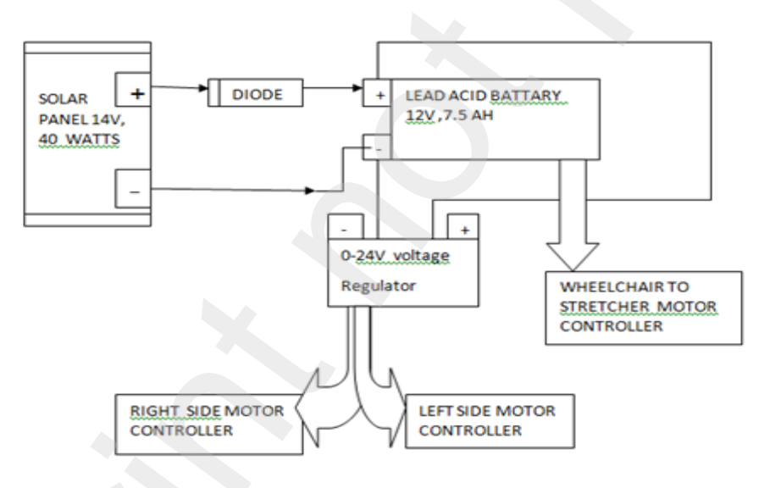
fig. block diagram

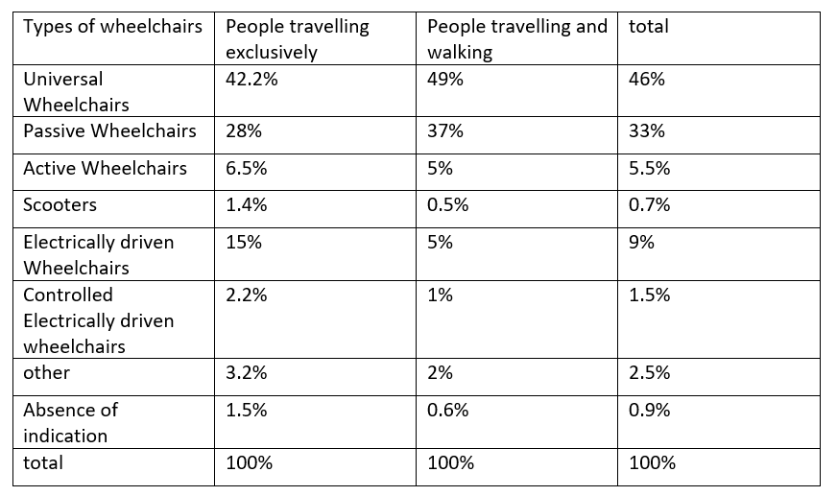

Fig. mainly used wheelchairs.

Ghorbel et explain about their wheelchair that They used ATMega328 Microcontroller, joystick, 16X2 LCD to display the readings the multiple sensors for making the system more convenient. Reddy and Kumar proposed the smart wheelchair, which connected to the mobile `They explained with the help of an accelerometer, RDIF tags voice recording system, and a GSM/GPRS module attempt to find a way to incorporate an IoT service device so that the status of the patient regularly updated on a web server.
They will be recognised quickly when any accident occurs with them in case of emergency. As the time passed researcher came with the solution of many problems about navigation, control, ergonomics the era when wheelchairs were invented did not had any navigation which leads to accidents. They all failed in challenging condition.
Machine leaning has taken the innovation to the next level, now it takes very less time to take the discission maybe in just fraction of second. The example of machine learning is neural network that use to detect the obstacles, advance SONAR sensors, advance joystick control. Obstacle histograms and SONAR information is combined and given to the joystick. Tyagi et al. 2013 use fuzzy control, which allows the use of inexpensive and imprecise sensors, keeping the overall system cost and complexity low.

Currently, high bandwidth, low-cost perception sensors can collect large amounts of data in real time, which requires significant computing power for the real time autonomous navigation for the smart wheelchair

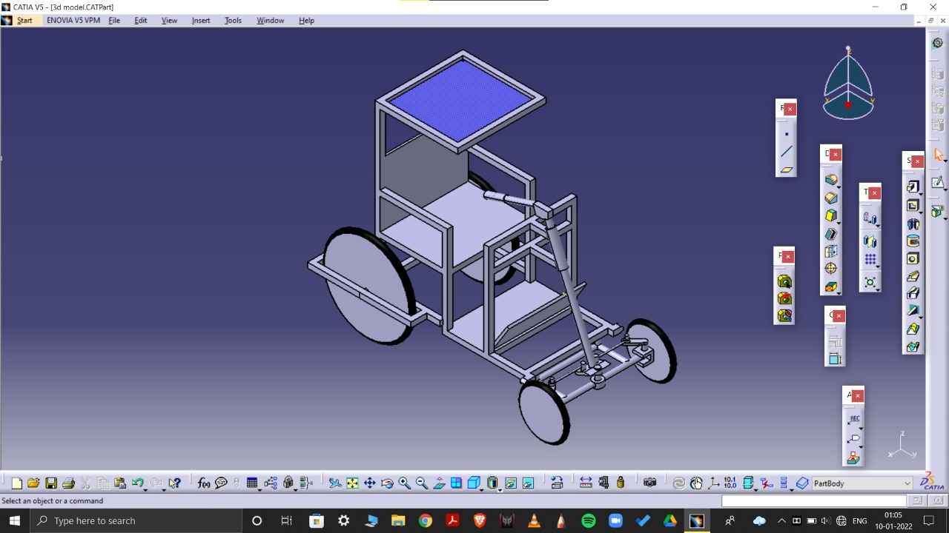
- system development
- joystick
• Joysticks were basically a simple arrangement of contact switches at four quadrants. Joystick use to translate the movement of a plastic stick into an electronic information
- Reinforced joysticks: The user is provided with a simple but effective control mechanism, and the joystick acts as the perfect fit for the particular operation.
Directional Buttons: As a convenience addition and a backup option a directional button system is also provided that takes input from the user.
- This basic design consists of a stick that is attached to a plastic base with a flexible rubber sheath. The base houses a circuit board that sits directly underneath the stick. The circuit board is made up of several "printed wires," which connect to several contact terminals. Wires extend from these contact points to the computer.

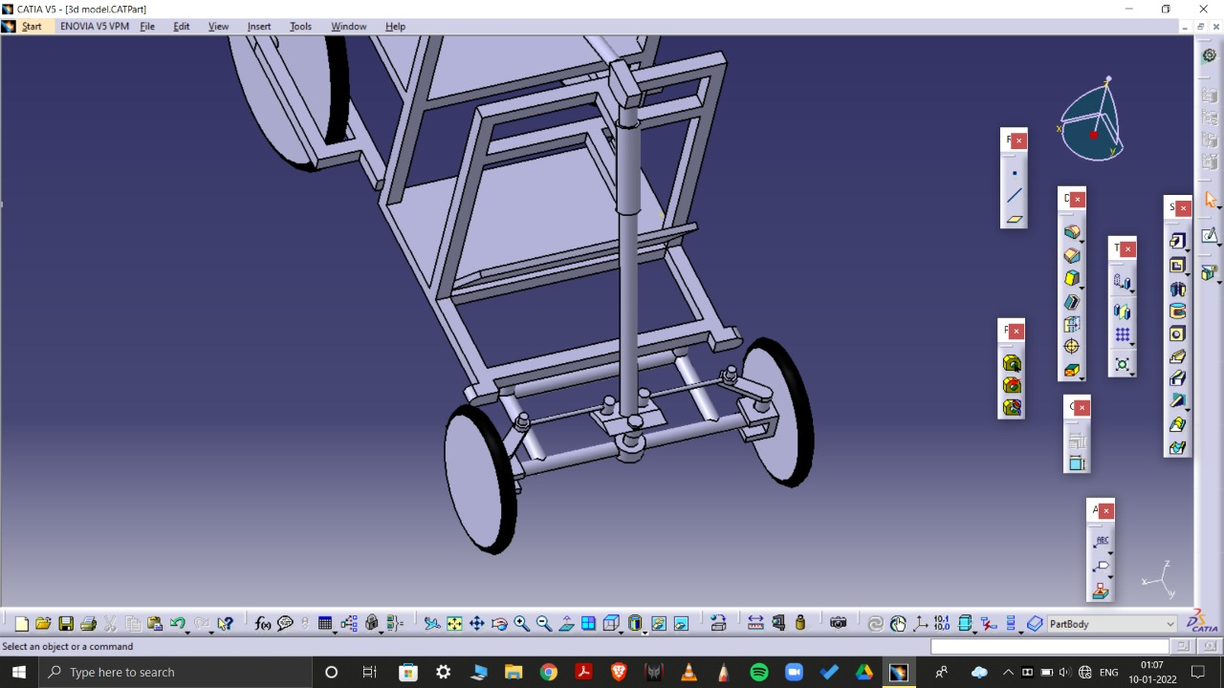
Fig.Front side driving mechnism.

- android control
• Mobile app-based control: For security reasons and for the sake of convenience, the chair has controlled by a mobile application. The family of the user (with some others) helps him that they can't interact with the system by themselves.
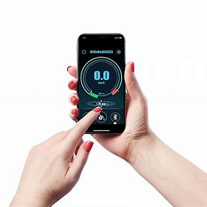

Fig. Mobile Control
- sensors
• Single switch control of the height of the footrest: The user can control the height of the footrest with a single switch control provided along with the directional buttons. In the next section, the proposed system explained. Some of the hardware and software components shown below:
- Peltier transducer:
As an alternative to commonly used passive colling technique
- temperature and humidity sensor:
for the measurement of temperature and humidity
- ultrasonic proximity sensor:
In sake of providing best of the best security to the user

d. motor
Motor which we have selected for the wheel chair is 24 V DC Geared. The operating current for the motor is 6 Amperes while maximum current is about 12 Amperes. The 3600 RPM motor has a rated power of 300 Watts. Motors a are directly coupled with the gear box of 24:1.

Some of the models use Brushless DC Geared electric motor (BLDC motor or BL motor), also known as electronically commutated motor (ECM or EC motor) having rating of 12V, 60 rpm is used.

e. Chain Sprocket
Chain sprocket mechanism is used to reduce the Rear Wheel torque. The sprocket has a gear ratio of 3:1 which will reduce the rear wheel torque by a factor of 3. Two chains and 4 sprockets are used for the driving mechanism. Smaller sprocket has 11 number of teethes and larger sprocket have 32 number of teeth. Our concern is with the smaller sprocket so motor gearbox is coupled with the smaller sprocket.

f. gearbox
Gearbox is used to bear more wight with less effort. The gearbox of 24:1 is used because of the max torque required to move 130 Kg weight of person in an ideal condition is 60.6 Nm from the calculations. The gearbox will enhance the motor torque which is 3.5 Nm to 84 Nm (3.5 x 24). Gearbox inserted after all the calculations are made so that the value of motor transmitted torque should be in the range.

g. battery

In the charging unit part, an AC 220 / DC 24V power electronic converter was made and the necessary charger was designed. There is a lighting unit in the outer casing to attract the attention of the disabled. The working principle of the charger made; Converting the AC voltage taken from the network to DC voltage, and reducing the converted DC voltage to a lower voltage value by means of a DC-DC converter.

The control of this converter is provided with the software designed using Arduino card. DC output is obtained by reading the card with a magnetic card reader (RFID) with Arduino. With the help of the solar panel, the spare battery is charged and the lighting around the charging station is carried out. Charging information and information about the station are reflected on the panel, with the help of the screen.

h. solar panel

slowly but steadily moving toward the renewable sources of energy as the non-renewable sources are on the edge of extinctions. The formation process of non-renewable energy sources require much more time but rate of consumption of these sources is significantly higher than its formation.
Solar is renewable source of energy; it is available all the seasons and production of energy from rays of sun is essential these days and also it is pollution free. We used solar panels to extract solar energy from sunrays. Solar panels are made up of PV modules.

- METHODOLOGY

The smart electrical wheelchair has BLDC Motor, Joystick for manual control, Application for digital control. We have use pair of BLDC Motor to provide better propulsion. To rotate wheel chair in right or left only one wheel rotate while other is stationary. When the rocker switch pushed forward the wheel connected to it will also rotates in the forward direction due to which the rack is pushed forward here both the ends of rack are connected to rods, the rod which is connected to backside of rack is connected to backside of chair while the front sided rod of rack is connected to legside of chair which further pushes the folding mechanism of the chair causing to convert the chair into a stretcher,
while the reverse direction of motor causes the stretcher to come back in the original shape that is into a chair. So, it is electrical basically requires the motor not required any oil or air so it’s not hydraulic and pneumatic so is light weight and required less space as well as low maintenance

Algorithm for the direction control of wheelchair
FCS=Forward
RCS=Right
LCS=Left
SCS=Stop
CS=Control Signal

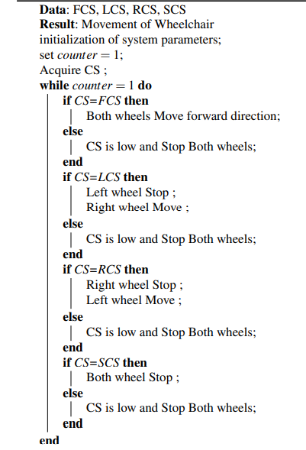

performance analysis
The wheelchair based on sEMG signal and hand gesture are shown in this figure. The results are based on the observations that are taken from the movement from the body muscle. These physical signals were converted into analog signals and then into digital signals.
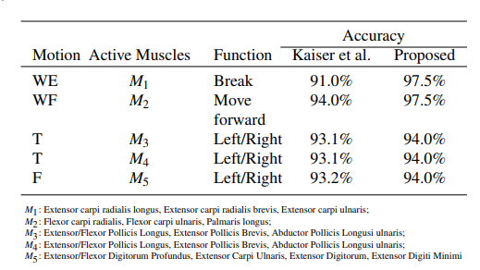

This observation table shows the position of sensor placed in the body and action associated with sensor. This figure also includes previously proposed system result over which this system provides significant improvement. It is clearly evident from the figure that newer system is provide much superior performance jump over the predecessor system up to 8%. The sensors were able to detect the motion of the person accurately.

LCC is tool use calculate the cost effectiveness of different type of the wheelchair. These calculations are perform considering that wheelchair will last at least 20 years. As, the battery

will definitely not last for more than 4 years so they take at least 4 replacements of the battery in count.

Table: LCC Analysis in USD
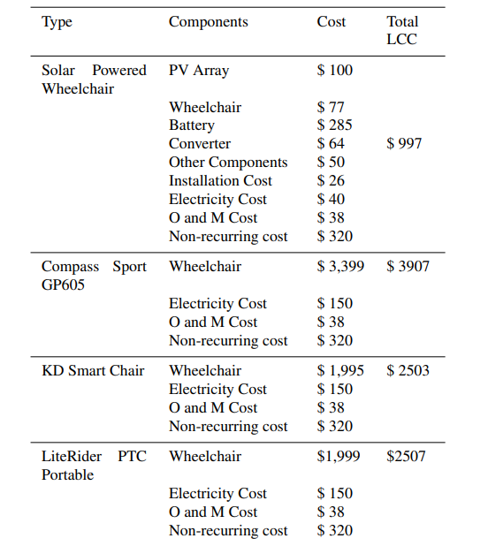

Above table represent the wheelchair available in the market with their cost. Table shows that now buying a wheelchair is financially feasible. Mostly the speed of solar powered wheelchair are less in order to provide comfort to a physically handicap person. It is approximately 3 to 4 km/hr in some wheelchair, but the wheelchair manufacture by IIT Madras is revolutionary and best in its own which is nearly identical to scooter for the handicaps. The name of the wheelchair is Neo-Bolt which has good speed and excellent shock absorbing capabilities.

conclusion

The paper explains about different kind of wheelchair available in the market with their performance, cost, features. We believe that these new techniques can bring to the wheelchair’s real capacities of intelligent action planning, autonomous navigation, and mechanisms to allow the execution in a semi-autonomous way of the user desires, expressed in a high-level language of command. The future sensor and technologies will bring new feature and at affordable price because it is not so hard to give new features and advancement to the wheelchair but it also increases the cost of the wheelchair. There is no any huge requirement of intelligent wheelchair because they are not cost effective. Charging process of solar pad is satisfactory it’s charging time can be minimize by using advance material for solar cells. Solar tracking system can be used to have better efficiency.

Our vision is to give best out of best and most useful feature to the wheelchair without burning the hole in pocket of physically handicap people.so if the wheelchair is not under the cost; you may not be allowed to blindly start the production as it will lead to the huge loss. Completion of this project needed sheer determination as there were many things that could go wrong. Though some difficulties aroused and many remodelling was needed and the chair had some limitations which we learned while building it, at last the Smart Wheel Chair created very close to the adapted design philosophy performance and Thanks to this smart system, disabled citizens are able to call the police, ambulance, fire brigade and their relatives with direct access on the touch screen in case of an emergency or in case of an emergency, as well as the ability of disabled citizens to control many objects on their chairs in a smart home system.

In today’s world huge need of charging stations, as solar cars and vehicle are introduced in the market and they are future of the transportation. Charging through solar is relatively slow and it may dry down in 4 to 5 hours. Charging stations are based on the renewable energy sources are need of the world.

FUTURE SCOPE

In today’s world a smaller number of people use wheelchair and solar added with advance technologies definitely increase the cost of the wheelchair which is not feasible for the everyone. If emerging technologies ca bring at lower price point every physically handicap person will be able to use smart solar electrical wheelchair.
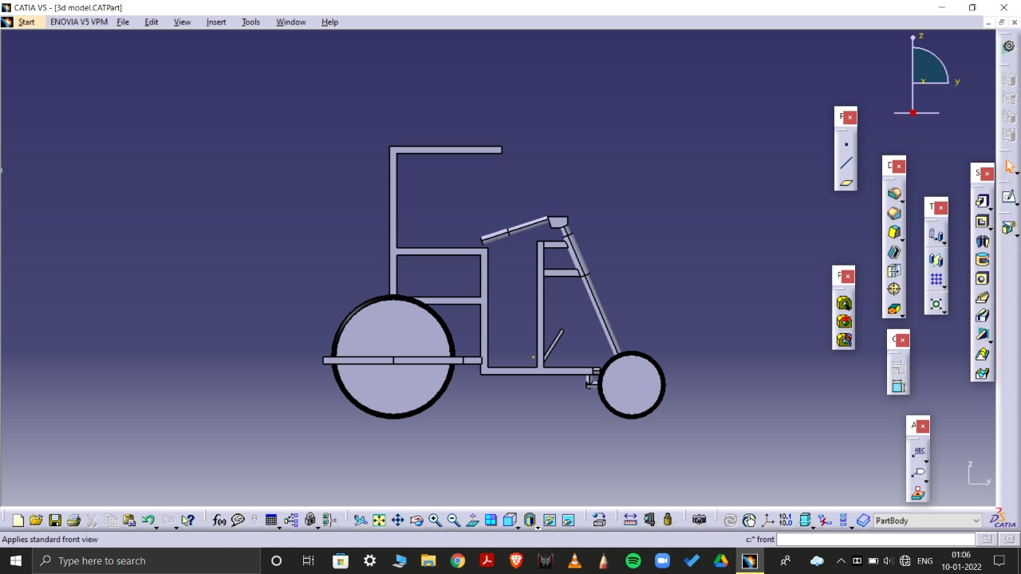
Fig. Side view of structure.

ACKNOWLEDGEMENT

The study is entirely based on the different model of the smart solar wheelchair available in the market. I have gone through all the research paper available till date on
the internet. After evaluation of all the type of wheelchair I have written this paper. Prof. V. S. Bhadane have provided me guidance for preparing the paper, I am sincerely thankful to them. I am also thankful to all my friends that are my group member.

References
[1] International Journal of Informatics and Communication Technology (IJ-ICT) Vol.7, No.2, August 2018, pp. 63~66 ISSN: 2252-8776, DOI: 10.11591/ijict. v7i2.pp63-66
[2] M. Shamim Kaiser Institute of Information Technology, Jahangirnagar University, Savar, 1342 - Dhaka, Bangladesh
[3] International Conference on Communication and Information Processing ICCIP-2020
[4] Ebrahimi A, Kazemi AR, Ebrahimi A. Wheelchair Design and Its Influence on Physical Activity and Quality of Life Among Disabled Individuals. Iranian Rehabilitation Journal. 2016; 14(2):85-92. https://doi.org/10.18869/nrip.irj.14.2.85
[5] 2020 Published in 8th International Symposium on Innovative Technologies in Engineering and Science 23-25 October 2020 (ISITES2020 Bursa - Turkey)
[6] International Journal of Engineering Research & Technology (IJERT) ISSN: 2278-0181
[7] International Research Journal of Engineering and Technology (IRJET). Volume:05

[8] https://en.wikipedia.org/wiki/Motorized_wheelchair

[9] https://en.wikipedia.org/wiki/Wheelchair

